晚上去 **世界最大的玻璃地板, 高速LED 墙电梯** <https://www.klook.com/zh-CN/activity/16870-king-power-mahanakhon-skywalk-ticket-bangkok/>

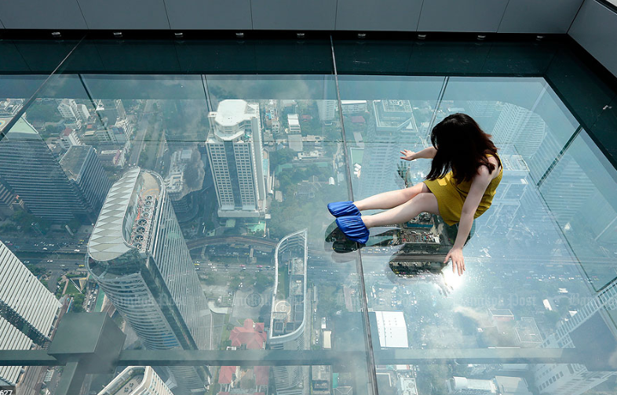

Opening Hours:

10:00am-12:00am, daily (last admission is at 11:00pm)

Address:

King Power MahaNakhon Tower, 114 Narathiwas Road, Silom, Bangrak, Bangkok

**水上市场，铁道市场 路线1**

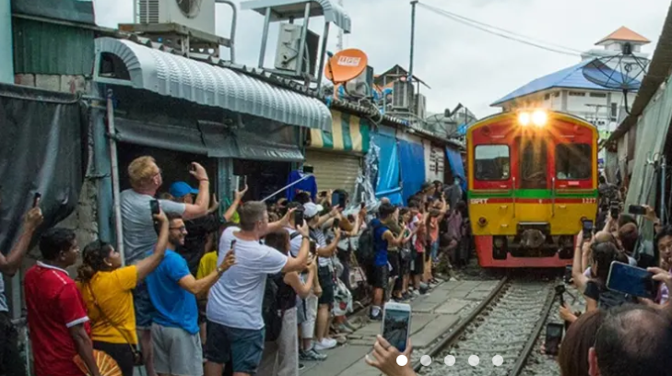

<https://www.klook.com/zh-CN/activity/3020-floating-markets-day-tour-bangkok/?krt=r22&krid=af0d86c2-3f96-4439-57d9-43a53baa98f9>

##### **Early Bird Day Tour from Siam Paragon (Daily)**

* 7:00am meet up at Siam Paragon Mall Gate 1 ground floor
* 7:30am depart from Bangkok to Damneon Saduak Floating Market
* 9:30am longtail boat ride (30-45 minutes) to the main part of the market. Explore the floating market or rent a paddleboat (at your own expense)
* 10:40am Maeklong Railway Market
* 12:30pm depart for Bangkok
* 2:30pm drop off at Icon Siam
* 3:30pm drop off at Asiastique
* 4:30pm drop off at Siam Paragon

##### **Day Tour from Century Mall (Mon-Thur)**

* 8:30am depart from Century Mall (next to BTS Victory Station)
* 10:30am Damnoen Saduak Floating Market (60 minutes electric boat ride)
* 11:30am explore the floating market on your own time
* 12:30pm Wat Bang Kung and Thai Boxing Temple
* 2:00pm Maeklong Railway Market
* 3:30pm-3:50pm experience the train
* 4:20pm depart to ASIATIQUE The Riverfront
* 6:20pm drop off at ASIATIQUE The Riverfront
* 7:00pm drop off at Chinatown
* 7:30pm drop off at Siam Center
* 8:00pm drop off at the original meeting point

##### **Day Tour from Century Mall (Fri-Sun)**

* 8:30am depart from Century Mall (next to BTS Victory Station)
* 10:30am Damnoen Saduak Floating Market (60 minutes electric boat ride)
* 11:30am explore floating market on your own time
* 12:30pm Wat Bang Kung and Thai Boxing Temple
* 2:00pm Maeklong Railway Market
* 3:30pm-3:50pm experience the train
* 3:50pm arrive at Amphawa Floating Market, explore on your own time
* 6:00pm 1 hour boat trip to see the fireflies
* 7:30pm depart for Bangkok
* 9:30pm drop off at original meeting point

**水上市场，铁道市场 路线2 （骑大象，芭提雅有更多）**

<https://www.klook.com/en-US/activity/2469-classic-tour-bangkok/?krt=r22&krid=af0d86c2-3f96-4439-57d9-43a53baa98f9>

##### **Day Tour**

* 8:30am meet up at Siam Paragon Mall Gate1 G floor
* 10:00am arrive Damnoen Sadauk Floating Market (30 minutes)
* Lao Tukluck Floating Market (approx. 1 hour and 30 minutes)
* Elephant Village (1 hour)
* Maeklong Railway Market (approx. 1 hour and 30 minutes)
* 5:00pm Asiatique the Riverfront or 5:30pm Siam Paragon Mall Gate1 G floor, can choose between two drop off locations
* After shopping at Asiatique, make your way back to the hotel on your own
* **Please note**: The itinerary and drop off timings are subject to change based on traffic conditions on the day of the tour (especially Fridays and Sundays) and may be delayed up to an hour

##### **[B2G1 Promotion] Day Tour**

* 8:30am meet up at Siam Paragon Mall Gate1 G floor
* 10:00am arrive Damnoen Sadauk Floating Market
* 11:30am Lao Tukluck Floating Market (approx. 1 hour and 30 minutes)
* 1:00pm Elephant Village (1 hour)
* 2:00pm Maeklong Railway Market (approx. 1 hour and 30 minutes)
* 5:00pm drop off at ICONSIAM Mall
* 5:30pm drop off at Asiatique the Riverfront
* 6:30pm drop off at Siam Paragon Mall
* After shopping at Mall/Asiatique, make your way back to the hotel on your own

Let's Relax Spa **泰式按摩**（由于可接待人数有限，第三方代订服务非百分百保证，Klook客路强烈建议至少提前1天通过电话或前往分店现场预约的方式）

<https://www.klook.com/en-US/activity/2124-lets-relax-spa-treatments-bangkok/?krt=r22&krid=af0d86c2-3f96-4439-57d9-43a53baa98f9>

Let's Relax是著名的泰式水疗，服务品质有口皆碑！独特的芳香精油，著名芳香热石，按摩全身，吃芒果糯米饭，曼谷有9家分店遍布

##### **伯克利酒店**

* 地址：559 The Berkeley Hotel, Pratunam, 10 Floor, Ratchaprarop Road, Kwang Makkasan, Khet Ratchathewee, Bangkok 10400
* [点击](https://goo.gl/maps/Xj1jdu91qFG2)查看地图
* 联系电话：[+66 23099999](tel:+6623099999)
* 电子邮箱： [lrbkl@siamwellnessgroup.com](mailto:lrbkl@siamwellnessgroup.com)

##### **文华Samyan店**

* 地址：Mandarin Hotel, 662 Rama IV Road (Samyan), Bangkok, 10500 Thailand.
* [点击](https://goo.gl/maps/9NnLS8nc1d82) 查看地图
* 联系电话：[+66 20428045](tel:+6620428045)
* 电子邮箱： [lrmdr@siamwellnessgroup.com](mailto:lrmdr@siamwellnessgroup.com)

##### **Ekkamai店**

* 地址：2nd Floor, Park Lane Community Mall Ekkamai Bangkok
* Ekkamai地铁站1号出口直行400米
* [点击](https://goo.gl/maps/v4Pe76nWDo42) 查看地图
* 联系方式：[+66 23821133](tel:+6623821133)
* 电子邮箱： [lrekk@siamwellnessgroup.com](mailto:lrekk@siamwellnessgroup.com)

**朱拉隆功大学**：泰国的第一所大学，也是泰国最负盛名的高等学府

**白天：曼谷大皇宫 & 玉佛寺**（不可以穿短衣短裤，中途不可取下，否则会被罚款2000泰铢, Men and women must be fully covered.），我们是搭grab 去集合地点但是因为司机说私家车不能进入大皇宫附近交通管制，所以距离一公里半的地方让我们下车， 走很久。需要grab taxi <https://www.klook.com/zh-CN/activity/22759-grand-palace-emerald-buddha-ticket-bangkok/>

#### Opening Hours:

* 8:30am-3:30pm, daily

#### Meet Up Information:

* Meet Up Time: 8:45am,10:45am, and 1:45pm
* Location: Starbucks at Tha Maharaj, please check the [map](https://www.google.co.th/maps/place/Starbucks/@13.7546448,100.4886393,21z/data=!4m8!1m2!2m1!1sStarbucks+at+Tha+Maharaj!3m4!1s0x0:0xf2bdc3a9bfd97dbc!8m2!3d13.7546879!4d100.4887664?hl=en) for reference
* Address: 1/11 Maha Rat Road, Phra Borom Maha Ratchawang, Phra Nakhon, Bangkok 10200
* Please look for the KLOOK sign
* Please be at the meet up location 10-15 minutes prior to the scheduled meet up time. No refunds will be given for no-shows and latecomers

**拉差达慕泰拳馆 Ratchadamnoen Boxing Stadium**

位置感觉算偏僻，没有地铁能到达，打车去70多泰铢，回来40多泰铢，去的时候是5点半曼谷很塞车所以走高速了，票价分为三档1000,1500,2500.大厅里面有两个票贩子，可以以低于官方价出售票给你，远处黑压压的都是来赌钱的，台上打得欢，台下赌得更欢，泰拳分为垫赛和正赛部分，其中垫赛是拳击，由轻量级的两个小拳手出场。后面的正赛有8-10场，是正宗的拳脚相向的搏斗。比赛场馆也很有趣，分为内场和外场，内场基本都是高官、游客和比赛团队，外场和内场被铁丝网隔开，外场基本都是来赌赛的，有人现场喊盘口。

晚上 **夜市 ASIATIQUE The Riverfront Bangkok - Exploring the Night Market before / after 看泰拳**Muay Thai Live: May Thai Knockout <https://www.klook.com/en-US/activity/9838-muay-thai-live-legend-lives-bangkok/>

Schedule:

* Tuesday - Friday and on Sunday: 8:00pm-9:30pm; Gate opens at 7:30pm
* Saturday Special Fights Broadcasted: 7:00pm-9:30pm; Gate opens at 7:00pm
* Closed on Mondays

Address:

* The Stage at Asiatique The Riverfront, 2194 Charoenkrung Road, Bangkok 10120, Thailand

**晚上：彩虹云自助餐，没什么特别**，网上只能订17点，19点 <https://www.klook.com/en-US/activity/685-sky-dining-buffet-bangkok/>

Bangkok Balcony Buffet in Baiyoke Sky Hotel's 81st

Redemption Process:

Once you arrive at the hotel, please check in at the 18th floor before proceeding to the 81st floor

Address:

Location: 81st floor of the Baiyoke Sky Hotel, 222 Ratchaprarop Rd., Ratchathewi, Bangkok 10400 Thailand

**克里普索人妖秀**是曼谷人气最高的秀场，就在河濱夜市裡，搭船遊河、吃飯、看秀、逛街一次完成！！

<https://www.klook.com/zh-CN/activity/361-calypso-cabaret-show-bangkok/>

**Madame Tussauds Bangkok 蜡像馆** <https://www.klook.com/en-US/activity/8555-madame-tussauds-bangkok-bangkok/?krt=r22&krid=af0d86c2-3f96-4439-57d9-43a53baa98f9>

go to the Klook exclusive skip-the-line lane

Opening Hours:

* Madame Tussauds: 10:00am-9:00pm, daily
* Last entry: 8:00pm

Address:

* Madame Tussauds, Siam Discovery, 6th Floor, 989 Rama 1 Road, Pathumwan, Bangkok 10330

**泰拳教练学习并切磋**

### 1. Chatuchak夜市

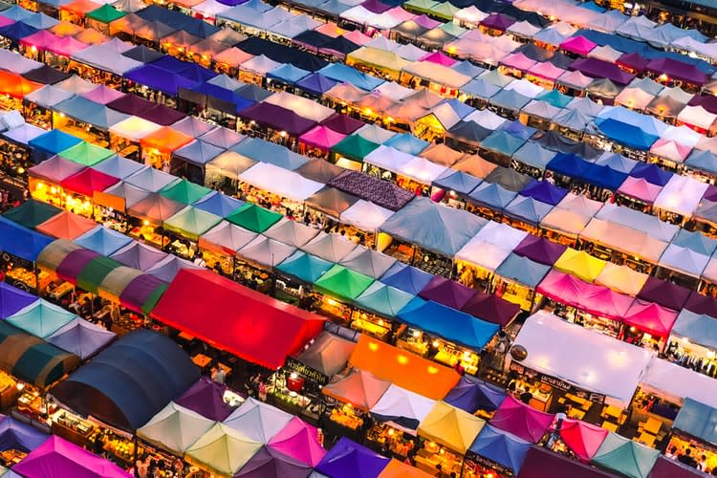

Chatuchak夜市也不用多介绍了，相信就算是去过还是没去过曼谷的也一定听过。这个人人都爱的曼谷夜市只有在周末才比较热闹，所以每到周末这里就会人山人海，因为要吃的有吃的，要穿的有穿的，这不就是来曼谷的其中目的吗？如果不想计划行程又想参观Chatuchak，不如试试看Klook的[丹嫩莎朵水上市场 & Chatuchak半日游](https://www.klook.com/zh-CN/activity/10954-damnoen-saduak-floating-market-chatuchak-weekend-market-half-day-trip-bangkok/?from_campaign=my_thailand-bangkok-night-markets_ao_zh-cn&from_medium=content&from_source=blog" \t "_blank)，让你毫无操心的旅行。

喜欢Fashion或美食，这里就是你的天地！甚至是道地的泰式甜点都有～不过这里算是旅游区，所以有些档口的价格可能会有些小贵，别忘了记得讨价还价！

如果你是超级美食家，又比较喜欢白天逛市场的话，不妨试试看[Chatuchak & 安多哥市场街头美食半日游](https://www.klook.com/zh-CN/activity/12333-street-food-hunt-chatuchak-aor-tor-kor-market-day-tour-bangkok/?from_campaign=my_thailand-bangkok-night-markets_ao_zh-cn&from_medium=content&from_source=blog" \t "_blank)，让你省下许多麻烦，又可以品尝到隐藏的档口小吃哦！

**战利品：**服饰、各种泰国美食、传统泰式甜点  
**地点：**Kamphaeng Phet 2 Road, 靠近Mo Chit BTS  
**如何抵达：**乘坐BTS到Mo Chit站，走向1号出口

[**CHATUCHAK & 安多哥市场街头美食半日游**](https://www.klook.com/zh-CN/activity/12333-street-food-hunt-chatuchak-aor-tor-kor-market-day-tour-bangkok/?from_campaign=my_thailand-bangkok-night-markets_ao_zh-cn&from_medium=content&from_source=blog)

### 2. Rod Fai夜市 (Ratchada夜市)

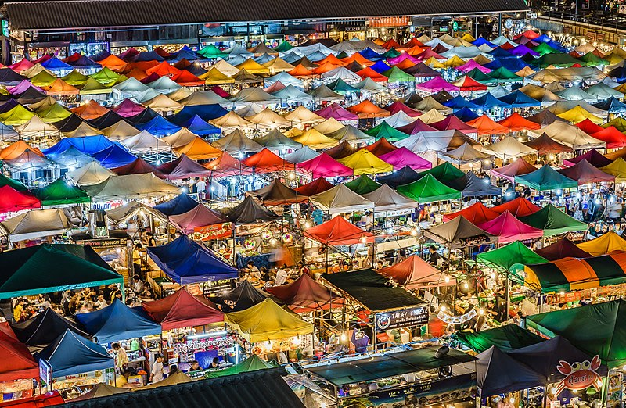

在Rod Fai夜市（又被称火车市场）可以享受许多超值的优惠和美味佳肴哦！这里的食物和物品价格都比较亲民，让你不用花大钱也可以吃遍夜市，收获满载而归～如果喜欢海鲜的话，Klook推荐可以尝试美式手抓海鲜料理「[Holy Shrimp](https://www.klook.com/zh-CN/activity/22661-holy-shrimp-bangkok/?from_campaign=my_thailand-bangkok-night-markets_ao_zh-cn&from_medium=content&from_source=blog" \t "_blank)」，超级海鲜盛宴震撼你的味蕾！

**战利品：**道地街头小吃、古董、服饰、复古服装  
**地点：**Ratchada Road，靠近Esplanade Mall和Thailand Cultural Centre MRT  
**如何抵达：**乘搭MRT到Thailand Cultural Centre站，走向3号出口。

[**在HOLY SHRIMP享用海鲜大餐**](https://www.klook.com/zh-CN/activity/22661-holy-shrimp-bangkok/?from_campaign=my_thailand-bangkok-night-markets_ao_zh-cn&from_medium=content&from_source=blog)

### 3. Saphan Phut夜市

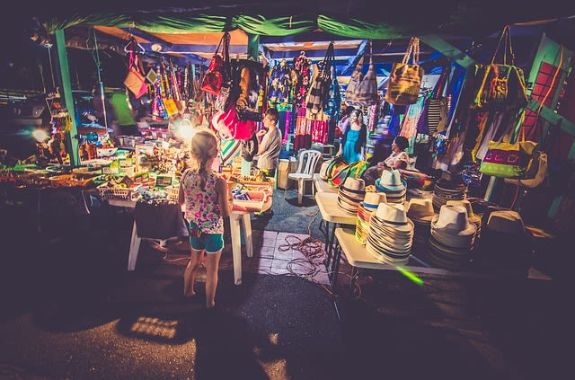

Saphan Phut夜市和一般曼谷夜市比较不一样，这里虽然小，但可以找到的战利品一点都不少！从时尚的服装服饰到各种食物小吃，应有尽有！如果你是喜欢冒险的人，这里还有纹身店，放胆去留下印记吧！

**战利品：**各种时尚包包和衣物  
**地点：**在Chakraphet和Maharat路，Memorial Bridge隔壁，  最方便抵达的方式是乘搭计程车  
**如何抵达：**乘坐BTS Skytrain到Saphan Taksin站，乘搭船往北，在Saphan Phut码头下船

### 4. The Owl夜市

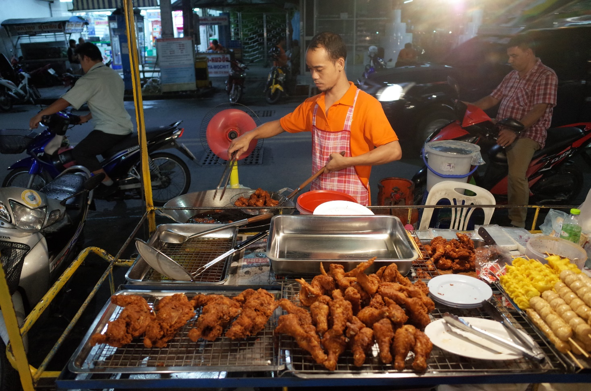

如果你自称是美食达人，那你一定会爱上The Owl夜市！这个跳蚤市场被称是隐藏般的夜市，多数只有当地人知道的宝藏哦！这里拥有最道地的泰国食物，每一个档口都能满足到你的味蕾！赶快把这个夜市也放进你的bucket list里～

**战利品：**任何泰国道地食物  
**地点：**Phra Chedi Nonthaburi 14/87 Moo 1, Nonthaburi 11000, Thailand  
**如何抵达：**乘坐地铁MRT到Yaek Nonthaburi 1，最近的地标是CentralPatza Rattanathibet。

### 5.河滨码头夜市Asiatique The Riverfront

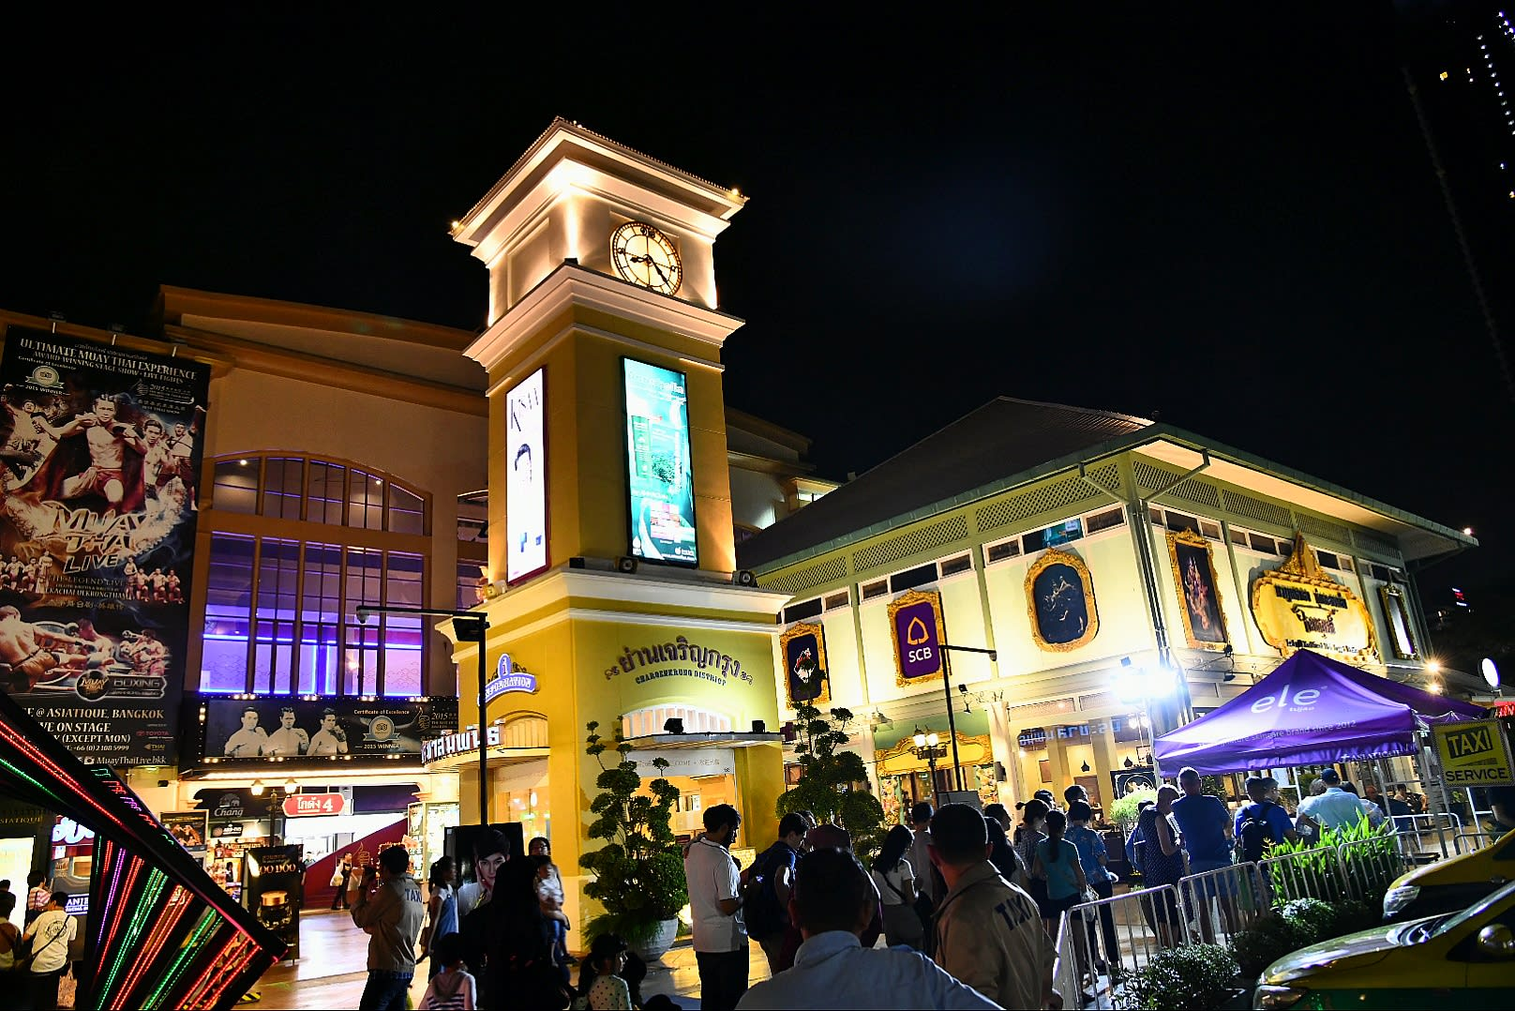

要是你好奇夜市和购物中心结合起来会是什么样子，来河滨码头夜市就对了！常听人家说，第一次曼谷一定要去参观Asiatique，因为你想要的东西这里几乎都可以找到～晚上的时候夜景更是不能错过，记得一定要准备相机打卡拍照哦！Klook特别推荐这里的[Happy Fish河岸景观餐厅](https://www.klook.com/zh-CN/activity/19907-happy-fish-bangkok/?from_campaign=my_thailand-bangkok-night-markets_ao_zh-cn&from_medium=content&from_source=blog" \t "_blank)，品味昭披耶河的迷人夜色，欣赏精彩万分的Live Band音乐表演～饭后甜点可以尝试[Mango Tango](https://www.klook.com/zh-CN/activity/21474-mango-tango-bangkok/?from_campaign=my_thailand-bangkok-night-markets_ao_zh-cn&from_medium=content&from_source=blog)，来杯甜而不腻的芒果饮料或甜品！

边吃饭逛街边享受河边夜景，只有Asiatique！

**战利品：**各个区域的美食、时尚单品  
**地点：**2194 Charoenkrung Road，Saphan Taksin BTS 站 (S6)  
**如何抵达：**乘坐BTS到Saphan Taksin站（S6），然后前往2号出口，再前往中央码头，然后搭乘免费渡轮前往Asiatique。

[**HAPPY FISH河岸景观餐厅**](https://www.klook.com/zh-CN/activity/19907-happy-fish-bangkok/?from_campaign=my_thailand-bangkok-night-markets_ao_zh-cn&from_medium=content&from_source=blog)

### 6. Changchui飞机夜市

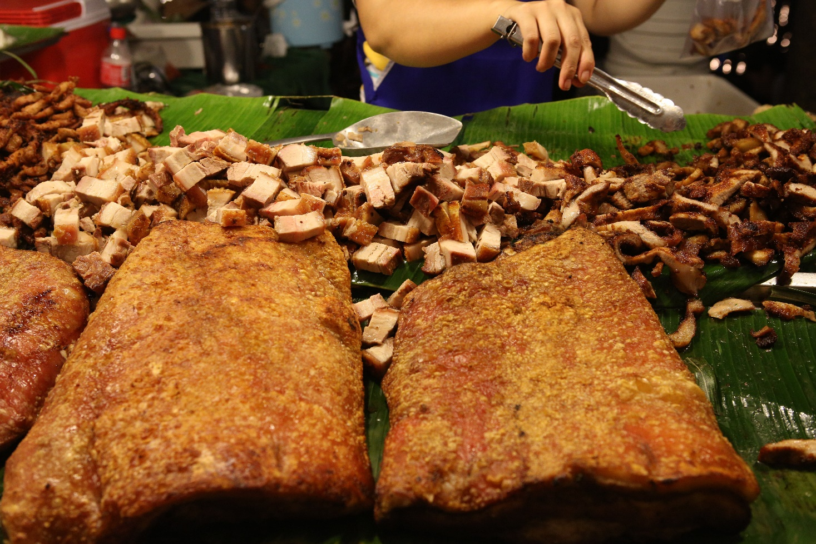

Changchui飞机夜市和传统的曼谷夜市不太一样，无论是规模还是档口都比较特别。从摊贩、商店、时尚餐厅、展览场所、艺术店，和大家所认识的夜市都有很大的不同，果然只有曼谷能超越曼谷了～

这里有一间餐厅叫「[Na-Oh Bangkok](https://www.klook.com/zh-CN/activity/20339-na-oh-bangkok/?from_campaign=my_thailand-bangkok-night-markets_ao_zh-cn&from_medium=content&from_source=blog)」，拥有独特的餐饮概念，带你前往未来主义的美食之旅～餐厅仿照圣经中的诺亚方舟（Noah’s Ark）改装的泰国喷气式飞机，让客人在内体验精致美食，感觉仿佛置身于不同世界！

**战利品：**当地泰国美食  
**地点：**462 Sirindhorn Rd, Khwaeng Bang Phlat, Khet Bang Phlat  
**如何抵达：**乘坐BTS到胜利纪念碑站（Victory Monument Station），然后乘坐515、539巴士在Bang Kruai下车。

[**NA-OH BANGKOK餐厅 – 曼谷飞机夜市**](https://www.klook.com/zh-CN/activity/20339-na-oh-bangkok/?from_campaign=my_thailand-bangkok-night-markets_ao_zh-cn&from_medium=content&from_source=blog)

### 7. Pak Khlong夜市

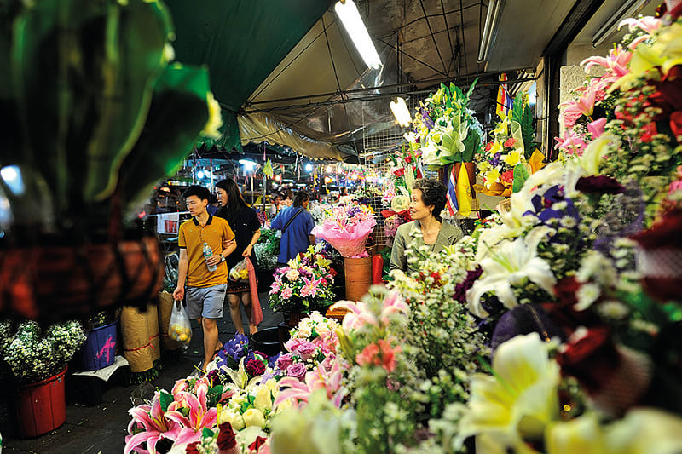

想要参观不一样的夜市，那就来Pak Khlong夜市吧！这里是曼谷最大的花卉夜市，每天24小时都在营业！不管是什么颜色和什么种类的花，保证你在这里都找得到！你可以购买小束的花，也可以购买一篮子的花，甚至是更多～买越多越便宜，还可以得到批发价哦！

**战利品：**各种类型的花  
**地点：**Chakphet Road and Saphan Phut在河边的Memorial Bridge附近。  
**如何抵达：**乘坐湄南河快船Chao Praya Express Boat在Pak Klong Talat北空塔拉德码头下车。

============================= 芭提雅===============================

**Pattaya Tiger Park Admission**

<https://www.klook.com/en-US/activity/27631-pattaya-tiger-park/?krt=r22&krid=a024f142-1c84-4a9e-684a-9f8b375d2f6a>

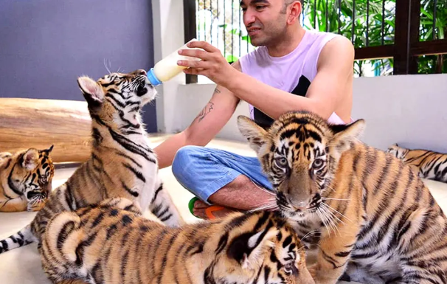

阁兰岛 <http://www.mafengwo.cn/photo/poi/6013326.html>

东芭乐园 大象表演和骑大象 <http://www.mafengwo.cn/photo/poi/18711.html>

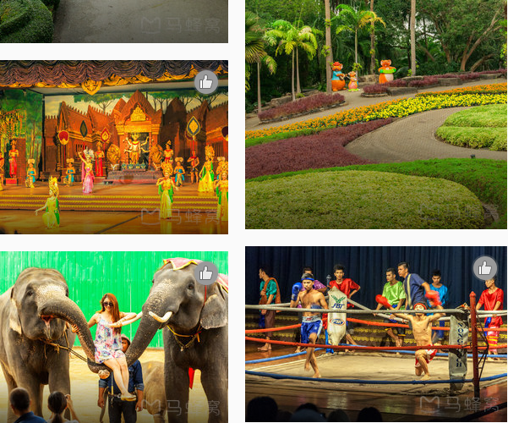

**芭提雅步行街** <http://www.mafengwo.cn/poi/6013329.html>

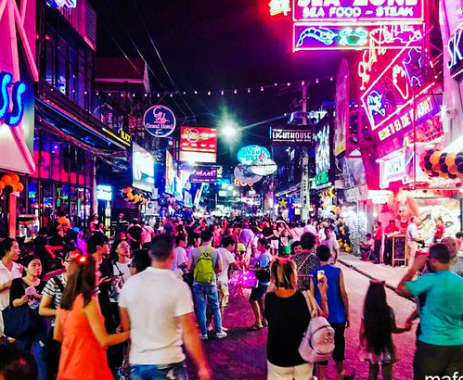

富贵黄金屋 <http://www.mafengwo.cn/photo/poi/6311153.html>

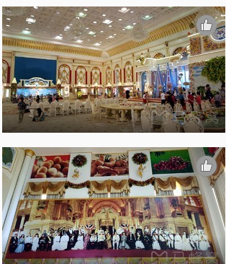

# **芭堤雅四方水上市场**

<http://www.mafengwo.cn/poi/14907.html>

**Koh Larn (Coral Island) Full Day Speedboat or Yacht Tour from Pattaya with Lunch**

<https://www.klook.com/en-US/activity/1168-coral-island-snorkeling-tour-pattaya/?krt=r22&krid=a024f142-1c84-4a9e-684a-9f8b375d2f6a>

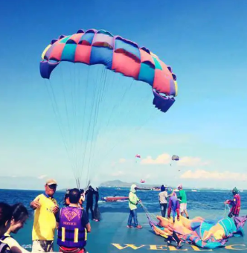 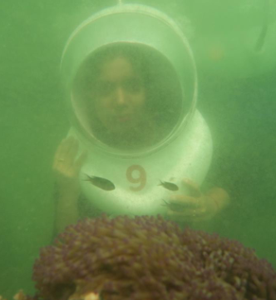

##### **Day Tour by Speedboat**

* 8:00am-9:30am appointment for customers at hotels in Pattaya and outside the zone
* 9:30am-9:50am customers will gradually enter the boat in front of Pattaya Beach. Going around takes about 10 minutes
* 10:00am arrive at Koh Larn Island (Tawaen Beach) and start Parasailling activities
* 11:00am sea walker activity
* 12:00pm jeski and banana boat riding activities
* 12:30pm lunch
* 2:00pm glass bottom boat see coral and fish
* 2:20pm snorkeling (Funny Land) at Sak Island
* 3:30pm travel back to Pattaya and send customers to the hotel

##### **Day Tour by Yacht**

* 7:00am-7:30am hotel pick up, depart for Ocean Marina Yacht Club
* 8:00am go aboard the yacht and depart from Ocean Marina Yacht Club
* 9:00am arrive at Koh Larn (Coral Island) to enjoy snorkeling, swimming, and fishing
* 10:00am free time to enjoy parasailing, sea walking, jet skiing, and banana boat (optional add-on) activities or relax on the beach
* 12:00pm enjoy a Thai and seafood lunch buffet
* 12:50pm depart from Koh Larn (Coral Island) to Ocean Marina Yacht Club
* 2:00pm arrive at Ocean Marina Yacht Club

类似的 **Koh Larn Island Full Day Tour from Pattaya with Snorkeling and Water Sliding**

<https://www.klook.com/en-US/activity/11516-full-day-koh-larn-island-tour-pattaya/?krt=r22&krid=935f5695-547c-4b5e-5450-84911bf26173>

##### **Sangwaen Beach**

* 8:10am-8:50am hotel pick up in Pattaya
* 9:10am arrive at Pattaya, parasailing activity (if availing), and depart to Koh Larn
* 10:45am arrive at Koh Larn and join beach activities according to package booked
* 1:00pm lunch and relax on the beach
* 2:30pm snorkeling and slider activities
* 4:00pm-4:30pm depart from Koh Larn to Pattaya
* 4:00pm-5:00pm hotel drop off in Pattaya

##### **Samae Private Beach**

* 8:30am-9:20am hotel pick up in Pattaya
* 9:30am arrive at Pattaya, parasailing activity (if availing), and depart to Koh Larn
* 11:30am arrive at Koh Larn and do banana boat and/or Jet Ski (if availing)
* 12:30pm lunch and relax on the beach
* 2:00pm snorkeling and slider activities
* 3:30pm depart from Koh Larn to Pattaya
* 4:00pm hotel drop off in Pattaya

**Pattaya to Koh Larn Half Day Tour** <https://www.klook.com/en-US/activity/11424-pattaya-to-koh-larn-half-day-tour-pattaya/?krt=r22&krid=935f5695-547c-4b5e-5450-84911bf26173>

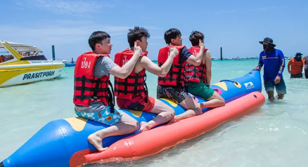

周末市场 <http://www.mafengwo.cn/photo/poi/6331099.html>

芭提雅康复之地按摩水疗中心

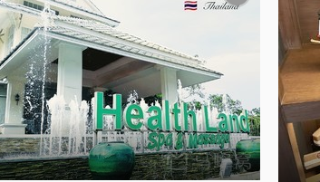

天堂艺术馆 <http://www.mafengwo.cn/photo/poi/32427242.html>

# **Pattaya ATV Adventure 90 美金，开两个小时**

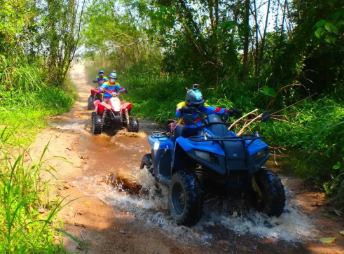

**Flight Of The Gibbon Chonburi US$ 117.89** <https://www.klook.com/en-US/activity/1108-flight-of-the-gibbon-tour-pattaya/?krt=r22&krid=935f5695-547c-4b5e-5450-84911bf26173>

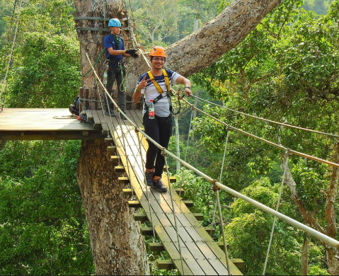 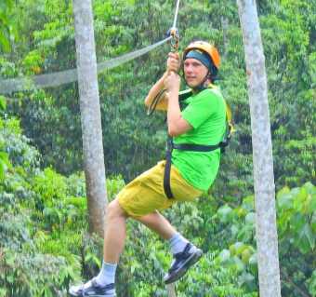

【泰國美食】12間曼谷地道餐廳 胡慧冲推介大大隻龍蝦麵

<https://www.gotrip.hk/408788/itineraryguide/thai_guide/%e6%9b%bc%e8%b0%b7-%e8%83%a1%e6%85%a7%e5%86%b2-%e7%be%8e%e9%a3%9f/>

02. 超級英雄咖啡店：The M Café 超級英雄figures作為主題 ，雖然這個地方由曼谷市中心坐的士來回都要大概200至300THB/HK$49-74，地址：Phuttabucha 36, Bangkok

電話：+66 81 918 8862營業時間：8:00am-7:00pm，逢星期三休息 網址：[www.facebook.com/Mcafegallery](http://www.facebook.com/Mcafegallery)

手信 <https://www.gotrip.hk/468719/itineraryguide/thai_guide/2019%e6%b3%b0%e5%9c%8b%e6%9b%bc%e8%b0%b7%e5%bf%85%e8%b2%b7-big-c%e8%b6%85%e5%b8%82%e6%89%8b%e4%bf%a1-%e9%9b%b6%e9%a3%9f-%e8%97%a5%e5%a6%9d/3/>

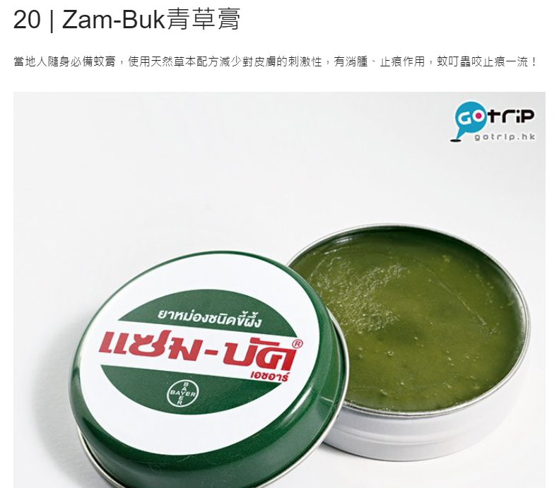

位於曼谷Din Daeng區的Mangkorn Seafood，是一間人氣海鮮 buffet 店。每位只需499銖，即可冇限時任吃十多種海鮮，還包飲品，是當地人常到的海鮮店之一！地址：1394 Soi Prachasongkhro 21 Prachasongkhro Road, Din Daeng, Bangkok時間： 4:00pm-3:00am電話：(+66)83-096-6379 facebook：mangkornseafood

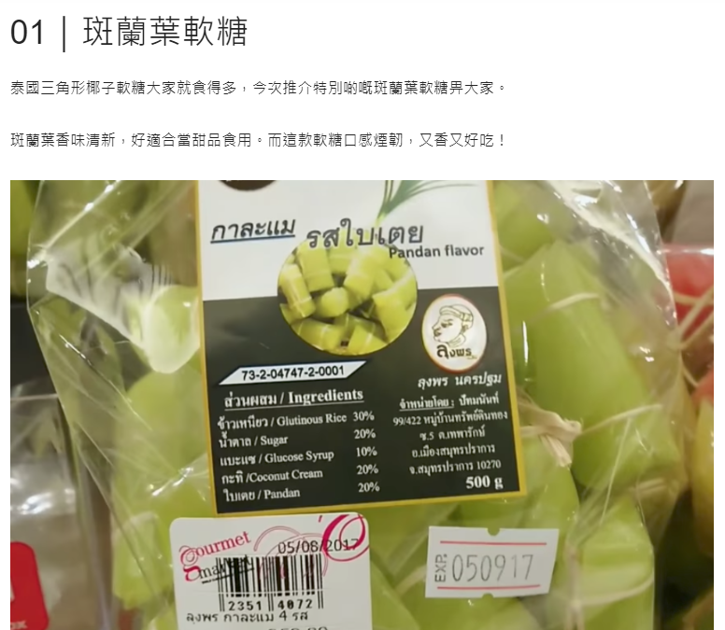

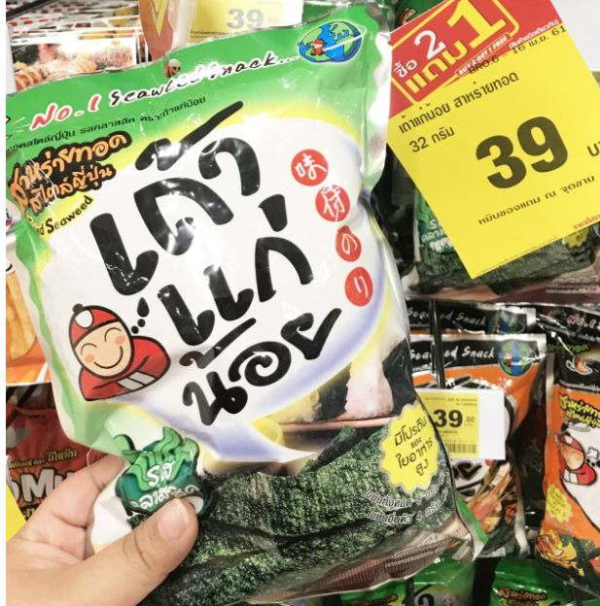

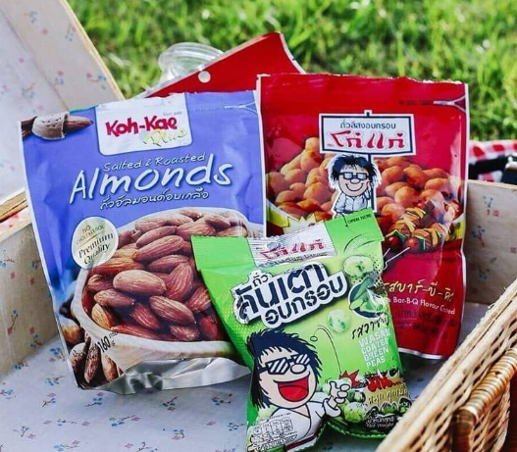

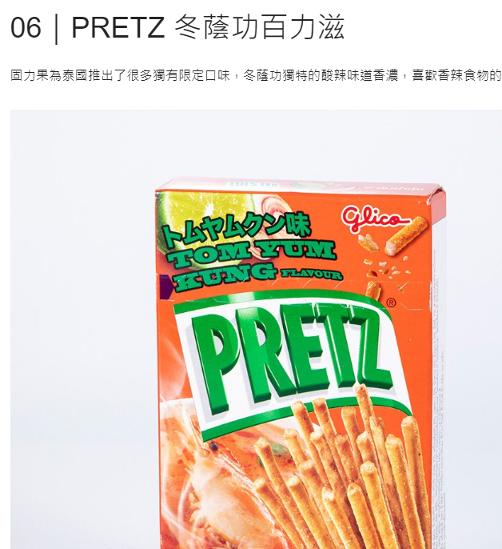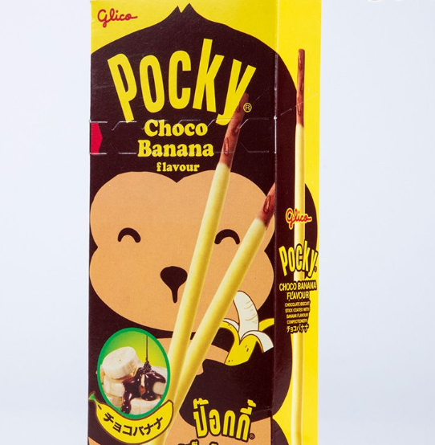

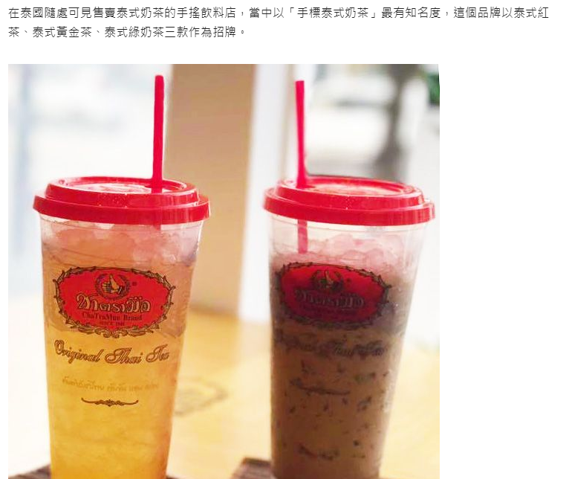

[**facebook@ChaTraMue**](https://www.facebook.com/ChaTraMue/)

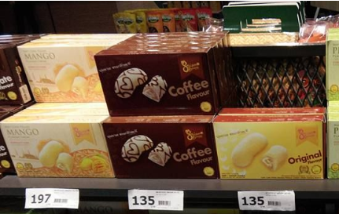

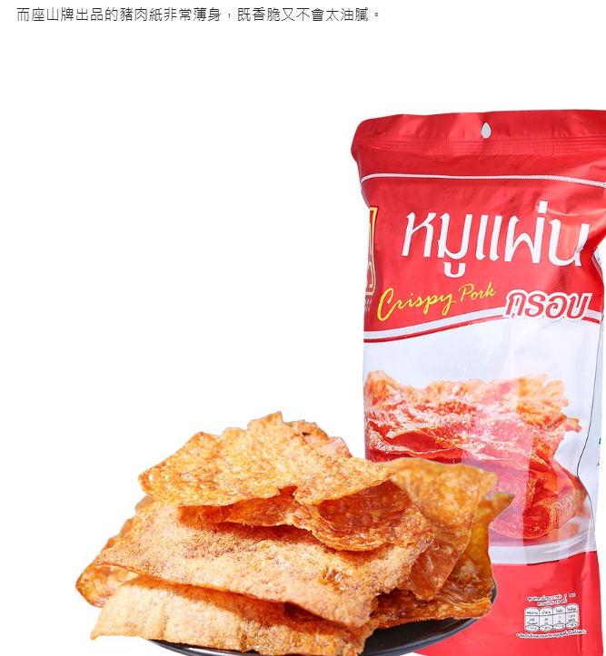

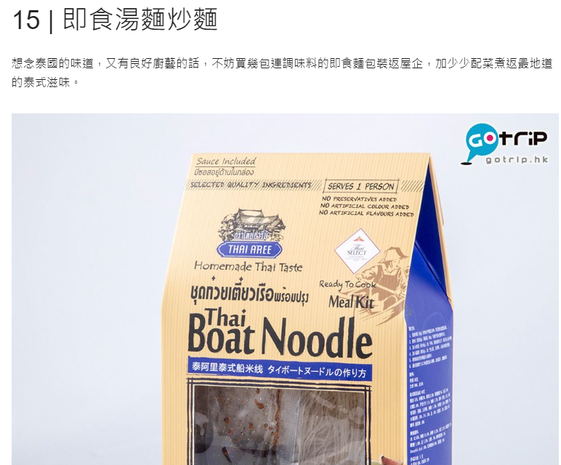

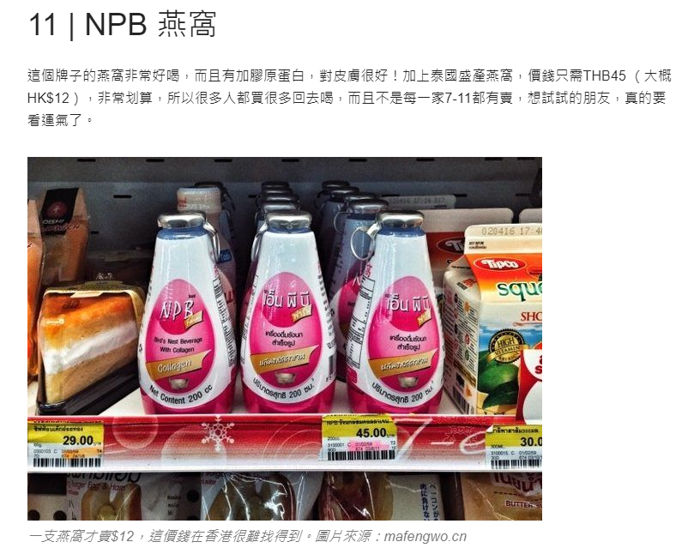

仙本那在另外一个岛，离吉隆坡2小时飞机

沙巴 → 亚庇 → 斗湖 → 仙本那

沙巴神山ATV （Mount Kinabalu ATV）接车准时七点，上车后还要接其他客人，汽车空调很猛，基本上我们一直都要带着薄外套。这个项目全程要开一个多小时，而且山路七拐八拐的。教练说以前也发生过很多，翻到水沟里的，骨折的，脚撞到石头结果指甲盖全部掀开的

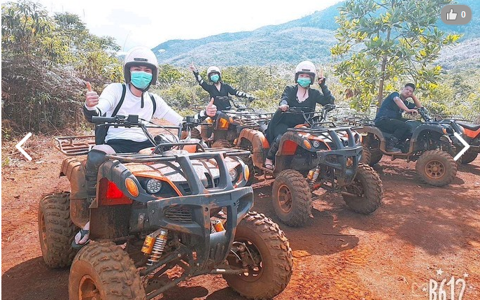

·曼达布安岛位于仙本娜的东北方向，有驻军，不允许太长停留。吃完饭和一军人同船去了附近潜点，浮潜也能看到如此美的海底世界。